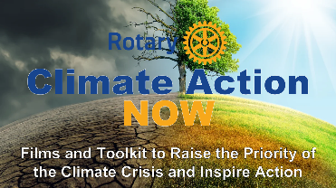
- Introduce Self & Team
  - Whoever is present or on zoom
- Thank Host and Club
  - President, other’s who facilitated visit
- Introduce the RCAN Project (brief history)
- We’ll have a Q&A period at the end, so please hang on to your questions until then.
- Also, all the materials you’ll see including the script films I’m using are in the RCAN Toolkit that I’ll talk about later in the presentation.
---------------------------------------------------------------------------------------------------
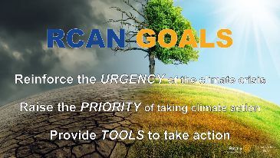
- Introduce RCAN GOALS:
  - Reinforce the urgency of the climate crisis.
  - Raise the priority of taking climate action.
  - Provide tools to take that action as a group and as individuals.
- Explain the Presumption:
  - The science is settled.
  - Burning fossil fuels and the resulting release of greenhouse gases into the atmosphere is the primary cause of climate change.
  - But something else is happening, and I’m here to talk about that and how we can all help.
- That something else is:
  - How the impact of burning fossil fuels has triggered natural feedback loops which make the situation even worse.
  - What we can do about it – as citizens and as Rotarians
  - How RCAN can help.

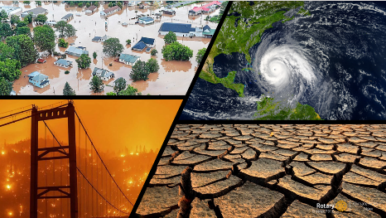
- We all know that today’s weather is not the same as it was just a few years ago.
- There have been climate disasters all over the world – including here. Hurricanes, intense flooding, wildfires, extreme heat, and drought.
- 2023 was by far the warmest year ever recorded.
- We’ve all asked ourselves why did it suddenly get worse, and how can we stop it.
---------------------------------------------------------------------------------------------------------------------------------------
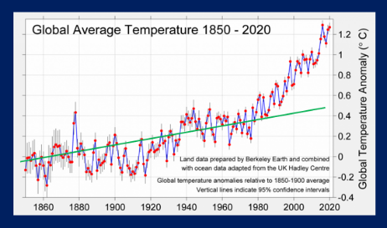
- You might have already seen this type of graph, or something similar.
- The straight green line shows the linear trend of temperature rise from the time of the industrial revolution as human activity began significantly adding greenhouse gases to the atmosphere.
- As we reached the 80’s the increase in global temperature started to accelerate – exceeding the predictions of many earlier scientific models
- Is something other than human activity adding to the problem?
- Is nature itself doing things that are adding to and accelerating the warming that we started?
---------------------------------------------------------------------------------------------------
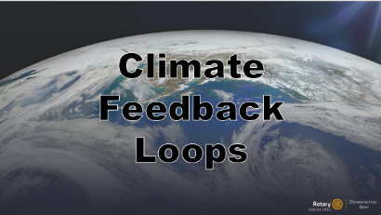
- In fact, our warming of the planet has set in motion a number of naturally occurring “climate feedback loops” that are significantly adding to the damage we are doing.

---------------------------------------------------------------------------------------------------
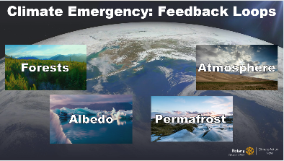
- While dozens of climate feedback loops have been identified so far, the RCAN Team is focusing on four major loops:

  - Forests: Which play a critical role in absorbing CO2 from the atmosphere. Because of the destruction of these forests through deforestation and wildfires their gigatons of stored CO2 is going back into the atmosphere, adding to the greenhouse gases we emit from burning fossil fuels.
  - Albedo (melting sea ice): As the polar regions warm, more sea ice and snow and ice on land melts. Highly reflective snow and ice are replaced with dark, light absorbing land and water, further warming the region. These Arctic feedbacks have warmed the Arctic four times faster than the global average.
  - Permafrost: The much warmer Arctic is thawing what was permanently frozen ground (permafrost), allowing bacteria to convert long frozen plant matter into the powerful heat trapping gas, methane – causing more warming. Note: I’d like to point out that “natural gas” is actually methane, a very damaging greenhouse gas.
  - Atmosphere: The greater warming of the poles in comparison to the mid-latitudes - where we live - has altered the Jet Stream and the Gulf Stream. This has impacted factors that determine when and where it rains and where it is dry, as well as intensifying storms.
- Each feedback loop has its own determining factors. The main thing they have in common is that:
  - As the planet heats up, carbon that was trapped safely is now being released into the atmosphere.
  - This causes temperatures to rise even faster.
  - Which causes more heat, more carbon release, etc.
  - And around and around it goes.
-----------------------------------------------------------------------------------------------
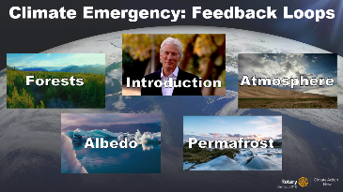
- PBS originally broadcasted the one-hour film “Earth Emergency”, and there are 4 shorter films which are a subset of that which cover the feedback loops I mentioned earlier: Forests, Albedo, Permafrost and Atmosphere.
- I want to share the Introductory film from this series with you tonight. It will explain Climate Feedback Loops more effectively than I can (plus Richard Gere has a better voice).
- The other 4 films in the series are online at FeedbackLoopsClimate.com, and you can watch them on your own if you wish.
- Let’s watch the introductory film now, and then have a talk about what you saw, and what we might do next.


- Show Introduction Film.

- Control-Click on the word INTRODUCTION on the slide to start the film.

---------------------------------------------------------------------------------------------------------------------------------------

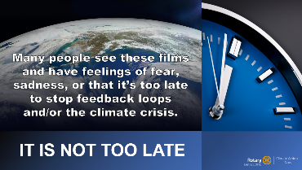
- If we warm the earth much more, warming feedbacks will reach a tipping point and become unstoppable.
- On the other hand, if we rapidly reduce the amounts of heat trapping gases in the atmosphere, the feedbacks will amplify cooling.
- The first time I watched these films, I was REALLY scared.
- But I was also motivated – because while each film talks about something terrifying, they each end with messages of hope and actions that we can take to slow and stop what we are doing to the our planet.
- By reducing our emissions, we can reverse these natural processes and restore the balance that humans need to survive on Earth.
- It’s not too late. We can still take action now that will help our children and grandchildren have a livable planet.
- But it’s important to take action that is impactful.

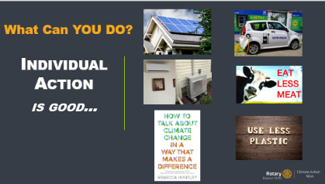
- Let’s talk about some of the options.
- There are lots of things you as an individual can do that will help.
- Review some of the actions on the slide, highlighting the following:
  - 1 gallon gas puts 20 pounds of CO1 into the atmosphere. So if your car gets about 40 miles/gallon you’ll generate a TON of CO2 for every 4000 miles you drive.
- Scientific American calculated that every pound of beef generates at least 15 pounds of CO2 (and this is a conservative estimate). More inclusive estimates go as high as 100 lbs.
- Highlight other actions that speak to you, even if they’re not on the slide, then continue below.
-------------------------------------------------------------------------------------------------
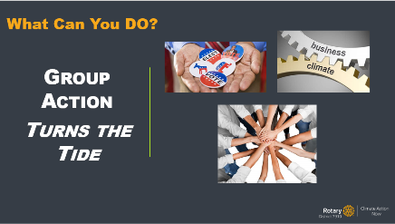
- Doing individual things is great – but group action is a game changer.
- Actions like supporting candidates or initiatives focused on impactful climate action. Make your voice heard.
- Getting your business or industry to lead the way – and become more successful too.
- Working with like-minded organizations and individuals to maximize your impact.
----------------------------------------------------------------------------------------------------
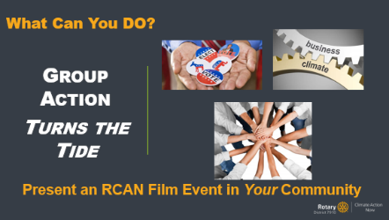
- In addition to the suggestions in the slide, an important way a Rotary Club can take group action is by hosting an RCAN Film Event in the community.
- Reveal the “Present an RCAN Film Event” line at the bottom of the slide.

- This would be an event almost exactly like this one, except it would be for a broader community audience. It would use a community-focused slideshow and script and a different “ask” – you’d be asking participants to take group action in the way that works for them.
- If you did one of these events you might show all of the films in one night and then lead a discussion on how to get people to take action using the toolkit. Or…
- Maybe have a film series over several nights, perhaps with the addition of atopic-specific speakers.
- You can design your event the way that works for your club and your community. The RCAN team will be there to help if you want us.
- I’ve emphasized group action. How do I know that group action works?
----------------------------------------------------------------------------------------------
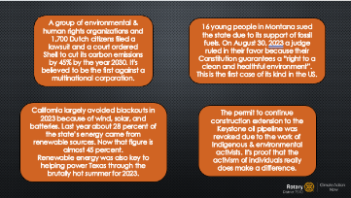
- Here’s how.
- I know there are a lot of words on this slide, but I want to give you a snapshot of what can happen when people prioritize fighting the climate crisis together.
        - Briefly summarize each actions as the slides progress. Stop before the polio image appears, then follow the script below.

- And this is just a small selection – there are plenty more, and later on I’ll talk about where you can find them.
- Of course, as Rotarians we are intimate with the power of what group action can actually accomplish. Note: reveal the polio image.
-----------------------------------------------------------------------------------------------------
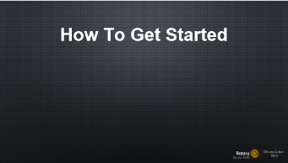
      - The RCAN team believes that people want to help – they want to leave a livable planet for the next generations. They want to take action.
- But, knowing what to do and how to get started is often a big obstacle.
-----------------------------------------------------------------------------------------------------
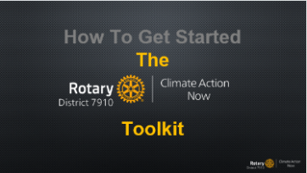
- So we made a toolkit to help overcome this problem.
- There are materials in the toolkit to help you to take group action OR individual action.
- It is an online, living set of resources. We’re adding to it almost daily.
- Right now it is in draft form in our Google drive, but we are in the process of porting it to its own website for easier access.
-----------------------------------------------------------------------------------------------------
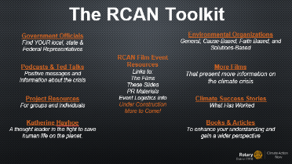
- We’ve organized it into categories to help people get started.
- It by no means covers every opportunity out there – the idea is to get people headed in the right direction.
- If you google “environmental action opportunities” (or something similar) you get an overwhelming amount of responses. The goal of the RCAN and the toolkit is help people get started and to motivate them to take impactful group action.
- Review some of the materials in the toolkit – the words in orange are live links so you can actually show the materials.
- For example, some people will never attend a march, but they are willing to make calls or send emails. Or, someone who HATES working on a computer might get fired up if they find an organization that gives them a way for hands-on action.
- An important section that is in development is how to hold an RCAN Film Event, like this one, for a larger audience and wider community.
- Talk more about Toolkit, take questions about it – generally ensure that people understand what is there.

----------------------------------------------------------------------------------------------------
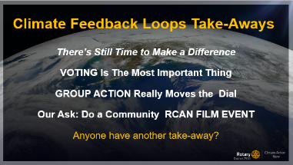
- I’ve shared a lot of information, and I hope you’ll take these important ideas home with you (read the takeaways).
- Voting is the most important thing anyone who lives in a democracy can do to fight the climate crisis.
- Vote for and support officials and candidates who take this problem seriously, have good ideas on how to solve it, or are willing to support the ideas of others and legislation that has solutions.
- Let me be very clear about one thing: RI encourages Rotarians to participate in their communities on important issues and does not consider the climate crisis a political issue.
- There are people across the political spectrum who understand the problem and want to solve it. Find those people, regardless of party affiliation, and support them.
One of the categories in our Toolkit is about Katherine Hayhoe. She is a climate scientist, a powerful climate action influencer, and a conservative Christian.
Note: if you’re running out of time, skip the following section about local boards & officials (it’s covered in the toolkit).
- Don’t just think nationally or regionally. Local officials and boards can have a big influence on what happens for a lot of people. Think about:
  - Planning and Zoning Boards for sustainable development and building.
  - Conservation Commissions for protection of trees, wetlands, and other carbon sinks.
  - Building Inspectors to encourage and enforce sustainable buildings.
  - Economic Development departments and personnel to get the business community on the right track.
  - Capital building committees for things like schools and libraries can influence whether buildings have sustainable materials and energy efficient components like heat-pumps, solar-ready system, and native plantings. Be sure to check out your local government.
  - Select Boards, Town Councils, and Mayors have a huge impact on environmental action in your town or city.

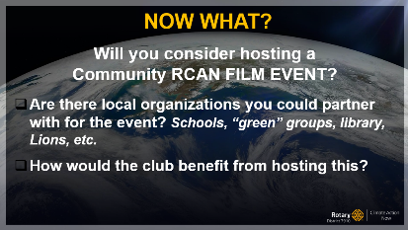
- Now it’s time to ask: Does hosting a Community RCAN Event seem like a good idea?
- If you’re interested, what do you think about partnering with another organization in order to expand your reach?
- How your club would organize itself to make it happen (for example, maybe a subcommittee will do it).
- What do you think the benefits of this type of event would be? (Environment, Club, community, etc.)
- Do you have other questions about this idea?

Note: try to get the group to discuss holding an event. Answer any questions, maybe try to help them understand what it might “look” like.
If appropriate, talk about the materials in the toolkit that are (or will be) designed for a club to do this: publicity, slideshows, scripts, etc.

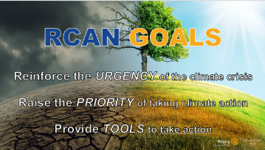
- As I mentioned at the beginning of this presentation, the RCAN Project has 3 goals:
  - Reinforce the urgency of the crisis.
  - Raise the priority of take climate action.
  - Provide tools to take that action as a group and as individuals.
- Hopefully I’ve achieved those goals (or will once you have a chance to watch the remaining films and look through the Toolkit).
- As I mentioned earlier, all the materials you’ve seen, including my script and films, are in the RCAN Toolkit.
- Hand out materials for them to access the toolkit.
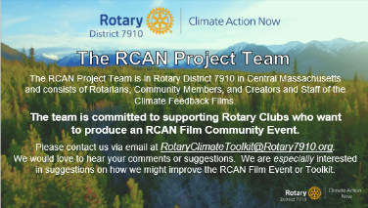
--------------------------------------------------------------------------------------------
- I really hope your club will seriously consider doing a Community RCAN Film Event.
- The team is here to help you do this if you need it.
- Does anyone have any other questions before we finish up? You can ask about anything – the films, the project, how you might want to take action….
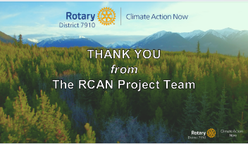
------------------------------------------------------------------------------------------------
- The RCAN Project Team is always interested in feedback about the presentation, toolkit, or really anything about the project.
- I have a VERY short survey about tonight’s presentation that I’d like to hand out. We encourage you to be brutally honest.
- Thank you to (host names) for having us here, and for your attention / listening.

